Installing and Using certificates for HL HIVE application

In order to use secure connections between various HIVE Plug-Ins you have to install a certain certificate previously. The certificate has to be generated and published by the machine that runs HIVE server application and therefore provides the WCF services.

Generating a new server certificate for secure messaging purposes
Normally, the certificate has to be generated by a domain controller (e.g. Microsoft Certification Services) and gets additionally validated by a third-party validation provider like VeriSign. When using certificates in a testing environment, a self-generated certificate can be used. To do so, you have to follow these steps to create a certificate on your machine that is used as server:

- Run the batch file “GenerateServiceCertificate.cmd”. It should be located in the same folder where this document is stored. When executing this file, you might get an error message (code: 0x5). This error occurs when you have insufficient rights on. In that case you must use some workaround described below. Otherwise proceed with step 2.
- Start the management console by typing “mmc certmgr.msc” into the command shell.
- Locate the generated certificate. The name of the certificate is “HIVE-Server” and normally placed in the Personal folder:

- Double-Click on the certificate and click on the Details tab:
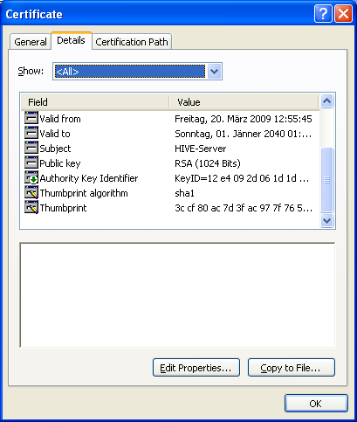
- Scroll down until you see the Thumbprint field:
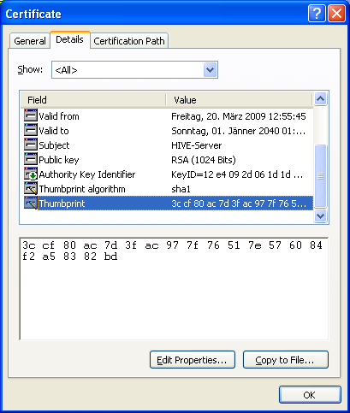
- Mark the displayed thumb print and use CTRL+C to copy it into the clipboard or save it into a text file. Now you can close the management console.

Workaround for Restricted Access on LocalMachine Store:
If you cannot create a certificate in the local machine store (defined by the –sr attribute) you have to choose the current user store. Therefore replace the option “-sr LocalMachine” with “-sr CurrentUser” and run the batch file again. This time the creation must be successful and the “Succeeded.” message should appear. Because the HIVE application normally looks in the local machine store for the correct certificate, you also have to change the settings in code which means you have to edit the WcfSettings file located in Hive.Client.Contracts . Set the StoreLocation attribute to “StoreLocation.CurrentUser” in the SetServiceCertificate() method and save the file.
Installing the server certificate on clients
When using a certificate for secure communication, you have to manually install a certificate on the client machine. When a validated server certificate is provided, those tasks can be performed automatically because the thumbprint won’t change.
Perform following steps to install the previously generated certificate:
- Open the batch file “InstallClientCertificate.cmd” with an editor.
- Depending on the used operating system select the correct tool and mark out the one you won’t use.
- Replace the current hash code (thumbprint) with the one you have saved before. Otherwise locate the service certificate on the server and perform tasks 4-6 from the previous chapter again.
- You should get a message displayed like “HttpSetServiceConfiguration completed with 0”. Otherwise you still have restricted rights to perform a http service configuration.

